Forecasting Wildfire Danger with Deep Learning: A Location-Aware Adaptive Normalization
Abstract:
Climate change is expected to intensify and increase extreme events in the weather cycle. Since this has a significant impact on various sectors of our life, recent works are concerned with identifying and predicting such extreme events from Earth observations. With respect to wildfire danger forecasting, previous deep learning approaches duplicate static variables along the time dimension and neglect the intrinsic differences between static and dynamic variables. Furthermore, most existing multi-branch architectures lose the interconnections between the branches during the feature learning stage. To address these issues, this paper proposes a 2D/3D two-branch convolutional neural network (CNN) with a Location-aware Adaptive Normalization layer (LOAN). Using LOAN as a building block, we can modulate the dynamic features conditional on their geographical locations. Thus, our approach considers feature properties as a unified yet compound 2D/3D model. Besides, we propose using the sinusoidal-based encoding of the day of the year to provide the model with explicit temporal information about the target day within the year. Our experimental results show a better performance of our approach than other baselines on the challenging FireCube dataset. The results show that location-aware adaptive feature normalization is a promising technique to learn the relation between dynamic variables and their geographic locations, which is highly relevant for areas where remote sensing data builds the basis for analysis
Introduction:
There is a general expectation that weather and climate extremes will change their patterns and frequencies in the future [1]–[4]. This is particularly the case for the Mediterranean region, which has been identified as a hot spot for climatic changes [5]–[7]. Because extreme weather events can impose short- and long-term risks in our Earth system, predicting these risks such as droughts, windstorms, and wildfires has become recently more relevant. In particular, wildfire forecasting constitutes one of the open challenges for risk assessment and emergency response [8]–[10]. Wildfire forecasting refers to the task of fire-susceptibility mapping using key remote sensing, meteorological, and anthropogenic variables [11]. Building an integrated modeling system of the Earth should also consider wildfire events to comprehend the origin of past patterns better and predict future ones [12]. Unlike typical prediction tasks, understanding when weather conditions have a high tendency to cause fire events addresses more complexities; among these are the stochastic nature of fire events [13] and fire drivers, which are time-dependent and inter-correlated across variables [14]. Moreover, the prediction model should consider difficulties like a high false positive error rate, uncertainty, and class imbalance.
In recent years, many works leveraged classical machine learning approaches to solve the task [11]. More recently, deep learning methods [15] have become popular since they can handle large multivariate datasets more efficiently and are able to learn highly complex relationships between observations and the predicted outcome. In the context of wildfire danger forecasting, Prapas et al. [16] and Kondylatos et al. [13] proposed to use recurrent neural networks in combination with 2D convolutions to exploit both temporal and spatial context. These approaches, however, do not distinguish between the different input variables. Static variables like elevation, which barely change over time, are simply copied and concatenated with dynamic variables like surface temperature. This results not only in a highly redundant input to the network, but it also neglects strong causal effects between static and dynamic variables. For instance, the surface temperature strongly depends on the geographical location, which is described by static variables.
Literature Survey:
Wildfire Danger Forecasting Wildfire forecasting or wildfire-susceptibility mapping from remote sensing and Earth observations data is a very important topic for wildfire management [11]. We briefly review some prior related works in this direction. Iban et al. [19], Pham et al. [20], and Gholami et al. [21] relied on traditional machine learning approaches to generate susceptibility maps. Shang et al. [22] and Mitsopoulos and Mallinis [23] utilized Random Forests classifiers (RF). In their works, they studied the importance of biotic and abiotic predictors for wildfire forecasting. Jiang et al. [24] proposed a deep learning approach based on a Multi-Layer Perceptron (MLP) and included a comparison with traditional machine learning algorithms. In Le et al. [25], a similar MLP-based approach was presented to generate a forest fire danger map. Zhang et al. [26] used a convolutional neural network (CNN) and extended their work later to predict fire susceptibility at the global level [27]. Other works with CNN were conducted in Bjanes et al. [28] and ˚ Bergado et al. [29]. Furthermore, Huot et al. [30] approached the problem as a scene classification task using U-Net models to predict wildfire spreading.
Multi-Branch Neural Networks When deep learning is applied to potentially multi-source remote sensing-based Earth observation data, multi-branch neural networks are a commonly used framework. This is mainly because such networks enrich representation learning and provide discriminative learning perspectives of the input variables [33]. In addition, an important aspect of the multibranch design is the capability to adapt some parts of the model to a specific type of input. The general framework generates features from each branch and fuses these features in the network to obtain a unified feature vector. This fused representation is used as input to the subsequent layers. In Gaetano et al. [34], a two-branch 2D CNN network was proposed to handle panchromatic information along with a multispectral one for image classification. Tan et al. [35] reduced the depth of a semantic segmentation classifier by applying consecutive blocks, each containing three CNN branches. A similar objective can be found in Zhao et al. [33], where the network complexity was reduced via weight sharing and self-distillation (SD) embedding. In this way, only the main branch is used during inference, which inherits the knowledge of trained subbranches and has a close performance to an ensemble model. For hyperspectral image classification, Xu et al. [36] introduced a model called Spectral–Spatial Unified Network (SSUN).

Conditional Normalization Since the introduction of normalization techniques in deep learning, they became a basic building block in many stateof-the-art models. Common normalization methods include batch normalization [47], group normalization [48], instance normalization [49], and layer normalization [50]. It has been shown empirically that normalization layers help with model optimization and regularization. Through normalization layers, the activation maps inside the model are normalized to follow a normal distribution with zero mean. After that, the normalized activation maps are modulated or denormalized by learnable affine transformation parameters. These parameters vary across channels and are learned based on the running training statistics together with the model parameters. Therefore, such a normalization method is called unconditional. Compared to popular unconditional normalizations, there exist conditional normalization techniques which aim to learn affine parameters conditionally on external input. In the field of computer vision, conditional normalization is often used for image synthesis and style transformation.
Existing System:
Current approaches for wildfire danger forecasting rely heavily on machine learning and deep learning techniques, leveraging data from remote sensing, meteorological, and Earth observation sources to predict fire susceptibility. Traditional machine learning models, such as Random Forests, have been used to generate wildfire risk maps, but they struggle to capture the complex relationships between diverse input variables. Recent advancements in deep learning have led to the adoption of neural network architectures, including Convolutional Neural Networks (CNNs) and Multi-Layer Perceptrons (MLPs), to better model the spatial and temporal aspects of wildfire risk. These models typically use static variables (e.g., elevation) and dynamic variables (e.g., temperature) as inputs but often treat them uniformly, leading to redundancies and overlooking significant causal relationships. Multi-branch neural networks have been introduced to enrich the representation learning process by processing different types of input separately. However, these architectures often suffer from a loss of interconnections between branches during feature learning, limiting their effectiveness. While conditional normalization techniques have shown potential in enhancing the model's ability to adapt to varying conditions, existing models still face challenges such as handling the stochastic nature of fire events, dealing with class imbalances, and reducing false positives in predictions.
Disadvantages:
Redundancy in Input Processing: Static and dynamic variables are often treated uniformly, leading to redundant data and failing to exploit the distinct characteristics of each type of variable.
Loss of Interconnections in Multi-Branch Architectures: The separation of branches in multi-branch neural networks can cause a loss of shared information during feature learning, limiting the model's ability to fully understand complex relationships.
High False Positive Rates: Existing models struggle with accurately predicting wildfire risk, often resulting in a high number of false positives due to the stochastic nature of fire events and class imbalance issues.

Proposed System:
The proposed system introduces a novel approach for wildfire danger forecasting using a two-branch convolutional neural network (CNN) that integrates both 2D and 3D convolutions. This system differentiates between static variables (e.g., elevation) and dynamic variables (e.g., temperature), processing them separately to reduce redundancy and better capture causal relationships. The 2D branch handles static variables, while the 3D branch processes dynamic variables, with Location-aware Adaptive Normalization (LOAN) modulating dynamic features based on geographic location. Additionally, the system employs sinusoidal-based encoding to provide explicit temporal context by encoding the day of the year, enhancing the model's ability to forecast fire danger accurately. Designed as a flexible architecture, the model can be adapted for other time-dependent forecasting tasks involving both static and dynamic variables. Experimental results on the FireCube dataset demonstrate the effectiveness of this approach, showing significant improvements in precision, F1-score, AUROC, and overall accuracy compared to existing methods.

Advantages:
Improved Accuracy: The separate handling of static and dynamic variables, along with Location-aware Adaptive Normalization (LOAN), allows for better capture of causal relationships, leading to more accurate wildfire danger predictions.
Enhanced Temporal Awareness: Sinusoidal-based encoding provides explicit temporal context, enabling the model to account for seasonal variations and improve forecasting performance over time.
Flexibility and Adaptability: The architecture is versatile and can be applied to other time-dependent forecasting tasks that involve both static and dynamic variables, making it suitable for a wide range of applications.

SYSTEM REQUIREMENTS

➢ H/W System Configuration:-

➢ Processor - Pentium –IV

➢ RAM - 4 GB (min)
➢ Hard Disk - 20 GB
➢ Key Board - Standard Windows Keyboard
➢ Mouse - Two or Three Button Mouse
➢ Monitor - SVGA

Software Requirements:
- Operating system : Windows 7 Ultimate.
- Coding Language : Python.
- Front-End : Python.
- Back-End : Django-ORM
- Designing : Html, css, javascript.
- Data Base : MySQL (XAMP Server).

Architectural Design
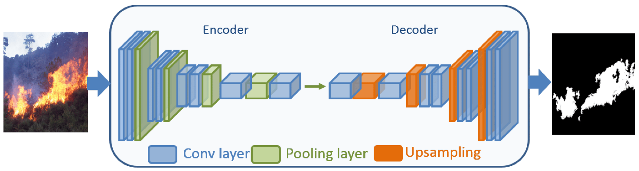
Flow Diagram
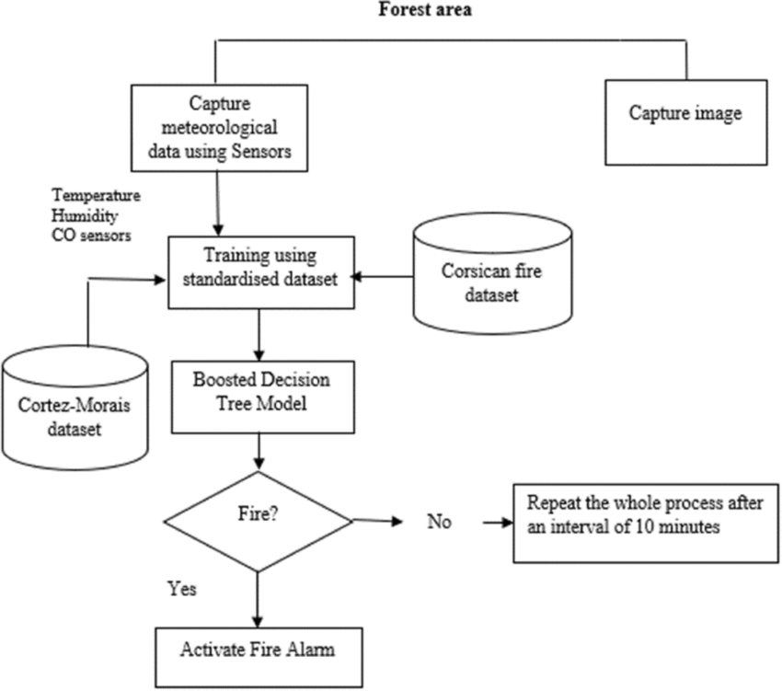
CONCLUSION:

In the pursuit of wildfire prediction, researchers have employed a variety of data sources, proposing diverse models and methodologies. However, a comprehensive and systematic review of these data and methods remains lacking, particularly in the case of deep learning techniques, which have seen rapid development and widespread application in wildfire risk prediction in recent years. This paper presents a thorough review of various wildfire driving factor data, feature collinearity, machine learning model interpretability, and wildfire risk prediction algorithms.
First, the development of wildfire prediction models requires multiple input data sources, as well as ground truth data for training and validation. These input data include fuel, weather, and climate conditions, topographical variables, hydrological features, and socio-economic factors. Researchers select different data sources and design appropriate data preprocessing workflows based on the characteristics of the study area and the availability of data. It has been found that most studies prioritize meteorological and climatic parameters, followed by fuel and terrain conditions, with socio-economic and hydrological factors being considered to a lesser extent. Additionally, to facilitate modeling for deep learning-based wildfire risk assessments, we introduced several publicly available wildfire burn prediction datasets, such as FireCube, Next Day Wildfire Spread, Wildfire DB, WildfireSpreadTS, CFSDS, and the SeasFire Datacube. Regarding feature collinearity and the interpretability of deep learning models, this review also highlighted the use of feature collinearity evaluation methods, including Variance Inflation Factor (VIF), tolerance, and Pearson correlation coefficients, as well as interpretability methods for deep learning, such as Permutation Feature Importance, Explainable Feature Engineering, and SHapley Additive exPlanations.

